To: Tahoe Science Advisory Council Regional Management Team
Tahoe Science Advisory Council Executive Committee

From: Robert Larsen, Council Program Officer
Date: March 17, 2021
Subject: TAHOE SCIENCE ADVISORY COUNCIL STRUCTURE ADJUSTMENT PROPOSAL
Overview
This memo provides organizational and process-specific recommendations to improve the Tahoe Science Advisory Council’s (Council) ability to coordinate with resource management agencies, prioritize projects, and better communicate scientific findings. Specifically, separating advisory and coordination roles from research projects can help enhance Council function.
Background and Status
The Tahoe Science Advisory Council (Council) is an independent group of scientists who work together in an advisory capacity to promote and enhance the use of the best available scientific information on matters of interest to both the states of California and Nevada. The Council offers expert, independent perspectives on pressing science issues and provides a venue for communication between research partners and land management agencies.
In recent years, the Council successfully led projects to identify research priorities for both Lake Tahoe and its surrounding watershed (upland ecosystems). The two resulting “Science-to-Action” plans provide the framework for future science investments to guide management action. With funding from the state of California, priority projects related to Lake Tahoe’s clarity are underway.
Concurrently, resource management agencies leverage Council expertise to inform the Tahoe Regional Planning Agency threshold standard update initiative, and to provide feedback on various scientific proposals, findings, and programs. The Council has provided both formal and informal peer review on topics ranging from downscale climate modeling to a Mysis shrimp harvest pilot project.
Opportunities for Council Improvement
There are opportunities to improve the Council’s ability to coordinate Lake Tahoe research and monitoring and to better support resource management activities. The challenges associated with science/management partnerships are shared by dozens of organizations throughout the country. The Tahoe region would benefit from incorporating best practices shared by other successful programs:
- Clarity in organizational purpose.
- Diversity of expertise and perspective.
- Transparency and objectivity.

Purpose
Institutions that lack a clear purpose often suffer from mission creep, and failure to focus. Fortunately, the Memorandum of Understanding (MOU) that established the Council provides meaningful organizational purpose and direction. At its core, the Tahoe Science Advisory Council exists to support resource management. In the resource management process, the Council’s role is to provide managers with the best science for decision making. The Council should use the MOU as a regular touchstone of its mission and purpose.
Diversity
Best practice suggests that diversity of expertise and perspective can improve management decisions and guidance. The Council enjoys participation from many members with extensive experience working the Tahoe region. Given the importance of the lake and associated metrics (i.e. clarity), several members are limnologists with differing specialties. Forest and fire scientists are also well represented. These two areas have been the focus of most Council activity to date. Tahoe is a complex socio-ecological system, however, and recent needs related to transportation and sustainable recreation have highlighted the Council’s limitations. There is also great potential for the Council to provide different perspectives on current topics and to bring new ideas to the Tahoe science conversation by taking advantage of the networks within individual institutions.
Transparency and Objectivity
The scientific method is grounded in an objective approach to collecting and evaluating information. At its core, science requires transparency of methods and replicability of results. Erosion of transparency and objectivity threatens the value of scientific advice.
The Council has been using informal processes to organize project teams and allocate available resources. Using priorities set by the Executive Committee and the Science-to-Action plans, the Council has developed individual project work orders, solicited member interest, selected project leads, and distribute allocated funds. While this approach has served the Council, there are opportunities for improvement, particularly as the Council budget grows.
Council members are asked to guide science prioritization efforts for work that they themselves are often best suited to conduct. This appearance of conflict of interest creates mistrust among resource management agencies and limits the implementation of Council recommendations. Separating the Council’s advisory functions from the project work could address this concern.
Structural Adjustment
The Council continues to evolve and mature as it completes projects, prioritizes science needs, and supports management activities. To better advance the Council priorities and to enhance the science/management partnership at Lake Tahoe, the Council should consider a series of modest structural adjustments enhance diversity, transparency, and objectivity.

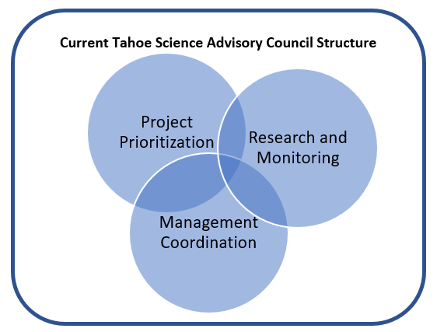
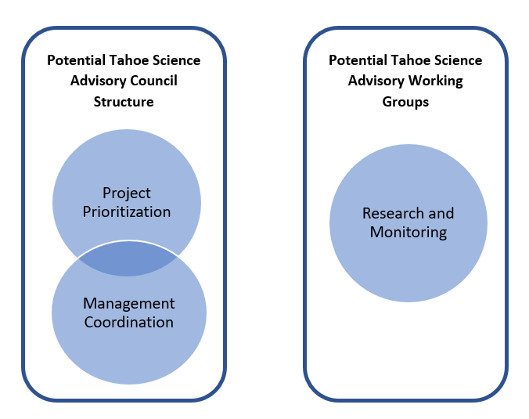
Figure 1: Current and proposed Council structure. As currently structured, the Council has taken responsibility for prioritizing projects, coordinating with management, and conducting research and monitoring efforts. Separating research and monitoring work from advisory functions would enhance Council objectivity and improve the Council’s ability to inform resource management decisions.

Specific Recommendations
- Rotate Council membership. Each Council institution should review Council membership and, where appropriate, propose a new member to be seated following the August 2021 Executive Committee meeting. Council members should be selected to provide a balance of experience and expertise. Member service terms should be limited with the potential for renewal.

Each institution should explore opportunities to add diversity of expertise to the Council with an eye toward adding informed and objective perspectives. Institutions are encouraged to discuss potential members with the Program Officer and the Regional Management Team.

One of the two institutional members should be chosen to support project planning, prioritization, coordination, and communication.

- Establish a Council Guidance Committee. This group can serve as a dedicated advisory body to decouple the Council’s prioritization, selection, and advisory roles from project implementation. Guidance Committee members should be selected from within the Council to prioritize fund distribution, solicit proposals, and select projects. The group could also lead general science agency coordination and facilitate science communication.

- Establish functional Science Working Groups. Working groups would provide the ability to maintain connection with the established science community while allowing the Guidance Committee to focus on objective recommendations. These working groups should include individuals from within Council institutions, including those that are not serving as Council members. Working Groups would respond to project solicitations, coordinate project implementation, and inform Guidance Committee activities.

Initial groups should align with current Council activities and could include one for Lake Tahoe water quality/clarity and another for upland ecosystems. These two groups would advance priorities outlined in the respective Science-to-Action plans. Additional groups will likely be needed for transportation and/or sustainable recreation as project needs arise and funds become available.

Next Steps
These structural adjustments should be codified in the Council’s Procedures and Protocols document. The Regional Management Team can provide review and approval of necessary document additions and edits. The Program Officer will summarize these issues and proposed program changes at the March 2021 Executive Committee meeting, with the goal of initial implementation by August 2021. The Program Office will also work with individual institutions to review Council membership and explore opportunities for broadening the Council’s perspective.

